**What is RFID (radio frequency identification)?**

RFID (radio frequency identification) is a form of [wireless](https://www.techtarget.com/searchmobilecomputing/definition/wireless) communication that incorporates the use of electromagnetic or electrostatic coupling in the radio frequency portion of the electromagnetic spectrum to uniquely identify an object, animal or person.

Every RFID system consists of three components: a scanning [antenna](https://www.techtarget.com/searchmobilecomputing/definition/antenna), a [transceiver](https://www.techtarget.com/searchnetworking/definition/transceiver) and a [transponder](https://internetofthingsagenda.techtarget.com/definition/transponder). When the scanning antenna and transceiver are combined, they are referred to as an RFID reader or interrogator. There are two types of RFID readers -- fixed readers and mobile readers. The RFID reader is a network-connected device that can be portable or permanently attached. It uses radio waves to transmit signals that activate the tag. Once activated, the tag sends a wave back to the antenna, where it is translated into data.

The transponder is in the RFID tag itself. The read range for RFID tags varies based on factors including the type of tag, type of reader, RFID frequency and interference in the surrounding environment or from other RFID tags and readers. Tags that have a stronger power source also have a longer read range.

## What are RFID tags and smart labels?

RFID tags are made up of an integrated circuit (IC), an antenna and a substrate. The part of an RFID tag that encodes identifying information is called the RFID inlay.

There are two main types of RFID tags:

* **Active RFID.** An active RFID tag has its own power source, often a battery.
* **Passive RFID.** A passive RFID tag receives its power from the reading antenna, whose electromagnetic wave induces a current in the RFID tag's antenna.

Low-power, embedded non-volatile memory plays an important role in every RFID system. RFID tags typically hold less than 2,000 [KB](https://www.techtarget.com/searchstorage/definition/kilobyte) of data, including a unique identifier/serial number. Tags can be read-only or read-write, where data can be added by the reader or existing data overwritten.

The read range for RFID tags varies based on factors including type of tag, type of reader, RFID frequency, and interference in the surrounding environment or from other RFID tags and readers. Active RFID tags have a longer read range than passive RFID tags due to the stronger power source.

smart labels are simple RFID tags. These labels have an RFID tag embedded into an adhesive label and feature a barcode. They can also be used by both RFID and barcode readers. Smart labels can be printed on-demand using desktop printers, where RFID tags require more advanced equipment.

**What are the types of RFID systems?**

There are three main types of RFID systems: low frequency (LF), high frequency (HF) and ultra-high frequency (UHF). Microwave RFID is also available. Frequencies vary greatly by country and region.

* **Low-frequency RFID systems.** These range from 30 [KHz](https://www.techtarget.com/searchnetworking/definition/kHz)to 500 KHz, though the typical frequency is 125 KHz. LF RFID has short transmission ranges, generally anywhere from a few inches to less than six feet.
* **High-frequency RFID system** These range from 3 [MHz](https://www.techtarget.com/searchnetworking/definition/MHz)to 30 MHz, with the typical HF frequency being 13.56 MHz. The standard range is anywhere from a few inches to several feet.
* **UHF RFID systems.** These range from 300 MHz to 960 MHz, with the typical frequency of 433 MHz and can generally be read from 25-plus feet away.
* **Microwave RFID systems.** These run at 2.45 Ghzand can be read from 30-plus feet away.

The frequency used will depend on the RFID application, with actual obtained distances sometimes varying from what is expected. For example, when the U.S. State Department announced it would issue electronic passports enabled with an RFID chip, it said the chips would only be able to be read from approximately 4 inches away. However, the State Department soon received evidence that RFID readers could skim the information from the RFID tags from much farther than 4 inches -- sometimes upward of 33 feet away.

## RFID applications and use cases

RFID dates back to the 1940s; however, it was used more frequently in the 1970s. For a long time, the high cost of the tags and readers prohibited widespread commercial use. As hardware costs have decreased, RFID adoption has also increased.

Some common uses for RFID applications include:

* pet and livestock tracking
* [inventory management](https://www.techtarget.com/searcherp/definition/inventory-management)
* [asset tracking and equipment tracking](https://www.techtarget.com/searcherp/feature/RFID-in-supply-chain-6-examples-in-use-today)
* inventory control
* cargo [and supply chain logistics](https://www.techtarget.com/searcherp/feature/Why-RFID-for-supply-chain-management-is-still-relevant)
* vehicle tracking
* customer service and loss control
* improved visibility and distribution in the [supply chain](https://www.techtarget.com/whatis/definition/supply-chain)
* [access control](https://www.techtarget.com/searchsecurity/definition/access-control) in security situations
* shipping
* healthcare
* manufacturing
* retail sales
* tap-and-go credit card payments

**RFID vs. barcodes**

Using RFID as an alternative for barcodes is increasing in use. RFID and [barcode](https://www.techtarget.com/searcherp/definition/bar-code-or-barcode) technologies are used in similar ways to track inventory, but there are some important differences between them.

|  |  |
| --- | --- |
| RFID tags | Barcodes |
| Can identify individual objects without direct line of sight. | Direct line of sight required for scanning. |
| Can scan items from inches to feet away, depending on type of tag and reader. | Require closer proximity for scanning. |
| Data can be updated in real time. | Data is read-only and can't be changed. |
| Require a power source. | No power source needed. |
| Read time is less than 100 milliseconds per tag. | Read time is half a second or more per tag. |
| Contain a sensor attached to an antenna, often contained in a plastic cover and more costly than barcodes. | Printed on the outside of an object and more subject to wear. |

**RFID vs. NFC**

Near-field communication (NFC) enables data to be exchanged between devices by using short-range, high-frequency wireless communication technology. NFC combines the interface of a smart card and reader into a single device.

|  |  |
| --- | --- |
| Radio frequency ID | Near-field communication |
| Uni-directional | Bi-directional |
| Range up to 100 m | Range less than 0.2 m |
| LF/HF/UHF/Microwave | 13.56 MHz |
| Continuous sampling | No continuous sampling |
| Bit rate varies with frequency | Up to 424 Kbps |
| Power rate varies with frequency | <15 milliamperes |

**RFID challenges**

RFID is prone to two main issues:

* **Reader collision.** Reader collision, when a signal from one RFID reader interferes with a second reader, can be prevented by using an anti-collision protocol to make RFID tags take turns transmitting to their appropriate reader.
* **Tag collision.**Tag collision occurs when too many tags confuse an RFID reader by transmitting data at the same time. Choosing a reader that gathers tag info one at a time will prevent this issue.

**RFID security and privacy**

A common RFID security or privacy concern is that RFID tag data can be read by anyone with a compatible reader. Tags can often be read after an item leaves a store or supply chain. They can also be read without a user's knowledge using unauthorized readers, and if a tag has a unique serial number, it can be associated to a consumer. While a privacy concern for individuals, in military or medical settings this can be a national security concern or life-or-death matter.

Because RFID tags do not have a lot of compute power, they are unable to accommodate encryption, such as might be used in a challenge-response authentication system. One exception to this, however, is specific to RFID tags used in passports -- basic access control (BAC). Here, the chip has sufficient compute power to decode an encrypted token from the reader, thus proving the validity of the reader.

At the reader, information printed on the passport is machine-scanned and used to derive a key for the passport. There are three pieces of information used -- the passport number, the passport holder's birth date and the passport's expiration date -- along with a checksum digit for each of the three.

Researchers say this means passports are protected by a password with considerably less entropy than is normally used in e-commerce. They key is also static for the life of the passport, so once an entity has had one-time access to the printed key information, the passport is readable with or without the consent of the passport bearer until the passport expires.

The U.S. State Department, which adopted the BAC system in 2007, has added an anti-skimming material to electronic passports to mitigate the threat of undetected attempts to steal users' personal information.

**RFID standards**

There are several guidelines and specifications for RFID technology, but the main standards organizations are:

* [International Organization for Standardization (ISO)](https://www.techtarget.com/searchdatacenter/definition/ISO)
* Electronics Product Code Global Incorporated (EPCglobal)
* International Electrotechnical Commission (IEC)

# Components of RFID Technology

RFID, or Radio Frequency Identification technology, has been around for decades. RFID is one of the cost-effective solutions that transfer data wirelessly within proximity.

## Components of RFID Technology

RFID technology consists of four components: RFID tags, antenna, RFID receiver (transceiver), and software.

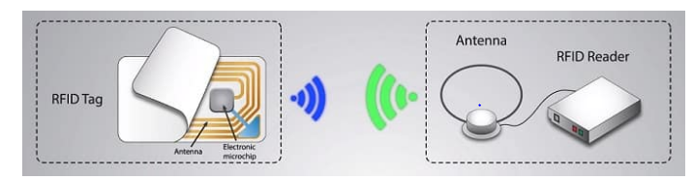

## 1. RFID Tag

RFID tags are small devices that consist of an electronic microchip embedded inside and an antenna. The microchip has the unique identification number of the RFID tag.

A passive RFID tag does not have a power source; it will receive power from radio signals transmitted from the RFID receiver. These tags will operate when the reader is in the proximity of the tags (line of sight not required).

#### Types of Tags

Passive Tags: Does not have a power source, uses power from the reader to operate.

Battery-Assisted Passive Tags: The logic circuit chip uses battery power. Need RF signals from the reader to activate and function.

Active Tags: Uses a power source like a battery and does not require power from the source/reader.

## 2. Antenna

RFID antennas are designed to operate at a specific frequency for each application in which it operates. These antennas are often mounted on the RFID reader and easily accessible for tags to tap on it.

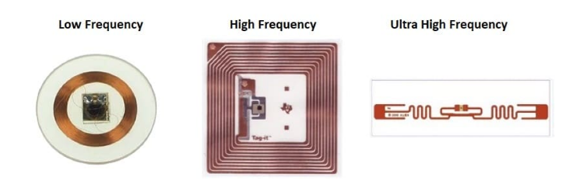

In some handheld devices, the antenna is often attached to the device. The size and shape of the antenna depend on the application and the system’s operating frequency.

## 3. RFID Reader

The RFID reader is one of the significant hardware components in the RFID system, which reads information from the RFID devices/tags and connects to the network to transfer the information to the database.

#### Specification of RFID Reader

Frequency: Operating frequency is one of the specifications of the RFID reader.

|  |  |  |
| --- | --- | --- |
| **Frequency Band** | **Range** | **Data Rate** |
| LF: 120–150 kHz | 10 cm | Low |
| HF: 13.56 MHz | 0.1–1 m | Low to moderate |
| UHF: 433 MHz | 1–100 m | Moderate |
| UHF: 865–868 MHz | 1–12 m | Moderate to high |
| 902–928 MHz |
| microwave: 2450–5800 MHz | 1–2 m | High |
| microwave: 3.1–10 GHz | up to 200 m | High |

## 4. Software

RFID technology uses specific software depending on service providers. This software controls the RFID reader, initiates a scan, retrieves information from the tags, and stores the information on a local computer or sends it to the cloud storage.

RFID tags can be erased and re-used using control software.

## How does RFID work?

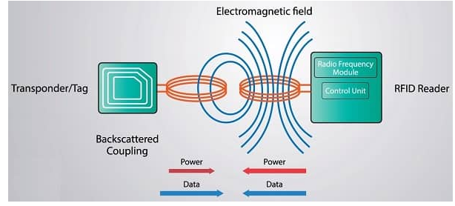

RFID technology works based on the principle of inductive coupling, including a source and receiver antenna. Each RFID tag will have a microchip that contains a unique identification number, model, manufacturing date, expiry date, access information, etc.…

RFID reading is a process of accessing information on a tag using a reader. When the user initiates a scanning, the tags are placed near the RFID reader or vice versa.

RFID reader sends radio frequency signals using its antenna; small coils embedded in the RFID tag pick up the signal from the reader and activate the tag (in passive tags) by powering it.

Once the tag is activated, it starts transmitting data back to the reader using the same antenna coils using the inductive coupling (backscatter coupling) method.

## What are the applications of RFID technology?

### 1. Retail and Supply Chain

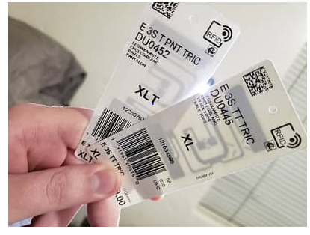

RFID technology is revolutionizing operational efficiency across the supply chain. Retail stores can efficiently manage stocks, and customers can access information about a particular product or self-checkout from the stores.

Many fashion retailers have already adopted the applications of RFID technology; it has helped them modernize their stores and improve customer satisfaction. RFID technology helps faster checkouts and reduces the number of support staff.

Theft control is another advantage of RDIF technology in retail stores. RFID readers will detect any items that pass through the exit without payment being completed.

### 2. Access control

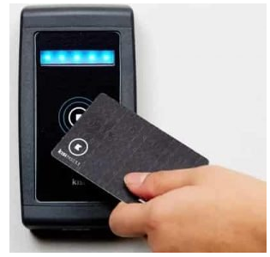

Access control and security is one of the common applications of RFID technology. Employers can assign different levels of access to each work group personnel in office environments, manufacturing plants, hospitals, airports, shops, etc.… Using modern RFID technology, a highly secure [access control](https://www.getkisi.com/industry/fitness) system can be implemented and monitored remotely.

Companies are using personal identification badges with RFID technology for employees.

### 3. Medical and hospital

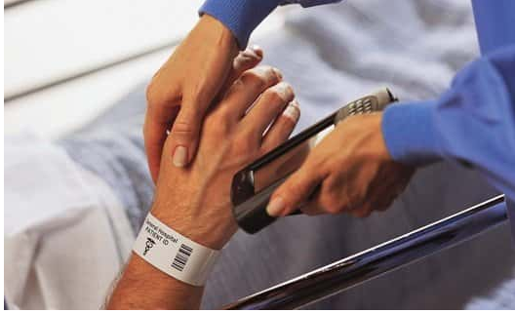

RFID technology can be used in medicine and healthcare to track the movement of medical equipment, update medicine stock, and authorize access for medical professionals. A simple RFID tag on a patient’s wrist does not require scanning (like a barcode scan); it helps medical practitioners efficiently handle patients for different procedures.

Implementation of RFID technology facilitates hospitals to improve efficiency, avoid errors during medication, and increase customer satisfaction. An RFID can store more data like personal information, allergies to some medicines, chronic conditions like diabetes, etc.

### 4. Logistics and shipping

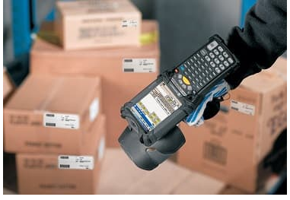

RFID tags were primarily developed to improve the efficiency of logistics and shipping. Manual recording of inventory movements is not feasible for larger quantities of items from the warehouse, manufacturing, and storage area.

RFID readers can easily read hundreds of tags within seconds with accuracy. Once the items move out of the warehouse premises, data will be updated in the database without manual action.

RFID gates are used for inventory management in big warehouse storage areas. RFID readers installed on the gates will record inventory movement in and out of a warehouse location.

### 5. Automation of manufacturing

RFID technology is one of the significant enablers for the smart factory concept to help automate different stages during manufacturing. During each stage of manufacturing, RFID readers will record the movement of products and update the database without additional action from the operator.

The application of RFID technology is suitable for large-scale production sites where hundreds or thousands of products are monitored, and status information is recorded in real-time. Manually updating this information is time-consuming and cause error while entering the data.

### 6. Animal tracking

Implementing RFID tags on livestock helps farmers update, identify, and easily track. Manually updating large amounts of data is not easy, especially in a remote location.

A handheld reader can easily access information (age, weight, vaccination data, etc.) within seconds. Veterinary doctors can retrieve information about a pet by scanning the tag (without going through records).

### 7. Baggage handling in aviation

The number of airline passengers has been increasing every year, and it will continue to grow in the coming years. Baggage handling a huge number of passengers is a heavy task for airlines; baggage mishandling often costs millions of dollars every year.

The efficient application of RFID technology helps airlines solve this issue and significantly reduce luggage mishandling. RFID tags do not require a line-of-sight angle to read information; this is an advantage compared to barcode scanning.

Tracking of baggage is much easier than other technologies; the operator will get a notification if the baggage is placed at the wrong location or moved to a different location.

RFID gate for inventory management, records in and out of a warehouse location

Advantages of RFID technology

* Cost-effective solution compared to other technologies
* Does not require a direct line of sight to operate
* RFID readers can read hundreds of tags simultaneously within seconds
* RFID tags can be rewritten and easily reused
* Data from tags can be encrypted for enhanced security
* Tags can store more information than just basic product information (serial number, lot number, manufacturing date, expiry, website URL, etc.)
* RFID systems can be integrated with other existing systems
* RFID technology is easily scalable and easy to implement

Limitations of RFID technology

* Signals from the RFID reader can be blocked by metal surfaces, liquids, and thick materials.
* Higher implementation cost compared to barcode scanners
* Accuracy is affected due to signal quality (any obstruction could cause an error in data)
* Implementation is more complex than the barcode system
* Privacy and security vulnerabilities often argued with the increased use of tags (especially personal information)